ANALYTICAL PROBLEM SOLVING

Warehouse Delivery Robot Pathfinding

Problem Statement
A delivery robot operates in a warehouse modelled as a 5x5 grid. It starts at cell (1,1) and must deliver a package to cell (5,5). The cells (2,2), (2,3), (3,3), (4,2) and (4,4) are blocked by shelving units. The robot moves Up, Down, Left or Right (no diagonals) and every move costs 1.
Notation: cells are written (row, column); row 1 is the top row and column 1 is the leftmost column.
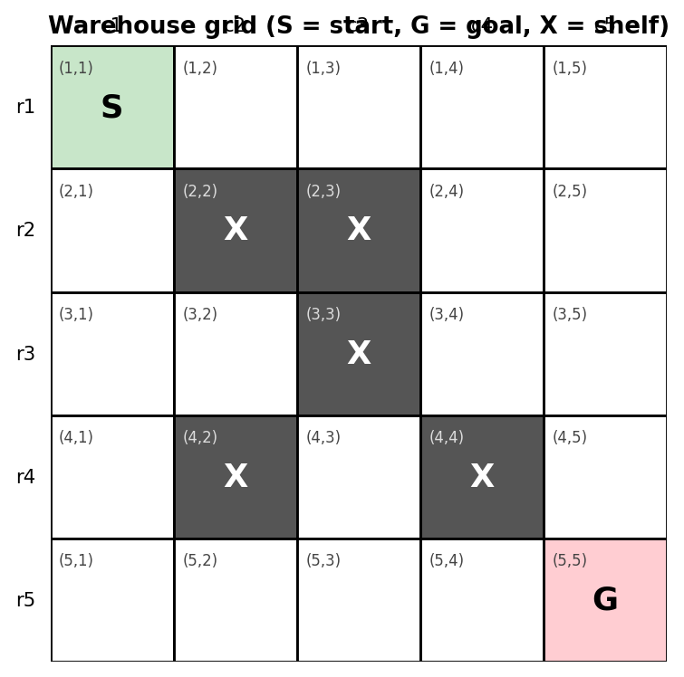
Figure 1: Warehouse grid (S = start, G = goal, X = shelf)

Key Observations
- The state space has 25 - 5 = 20 free cells.
- Cells (3,2) and (4,3) are dead ends: (3,2) is enclosed by (2,2), (4,2) and (3,3); (4,3) is enclosed by (3,3), (4,2) and (4,4).
- The Manhattan distance from (1,1) to (5,5) is |5-1| + |5-1| = 8, so no path can cost less than 8.

Part (a) - PEAS Description

a.1 Agent and Task
The agent is a warehouse delivery robot. Its task is to carry a package from (1,1) to (5,5) through the shelving layout shown in Figure 1.

a.2 PEAS Table

Component | Description for the warehouse robot
Performance measure | Reach (5,5) and deliver the package (success); minimise total path cost (number of moves, best = 8); never enter a blocked cell or collide with shelving; minimise time and battery use; deliver the package undamaged.
Environment | 5x5 warehouse grid with 20 free cells and 5 blocked shelving cells (2,2), (2,3), (3,3), (4,2), (4,4); start (1,1); goal (5,5); the package carried by the robot.
Actuators | Drive motors / wheels for Up, Down, Left, Right moves; steering and braking; gripper or carrier platform to hold and release the package.
Sensors | Position sensor (wheel encoders, RFID floor tags) giving the current cell; obstacle sensors (ultrasonic / LiDAR / bumper) to detect shelving; camera or marker reader to recognise the goal cell; package-load sensor; battery sensor.

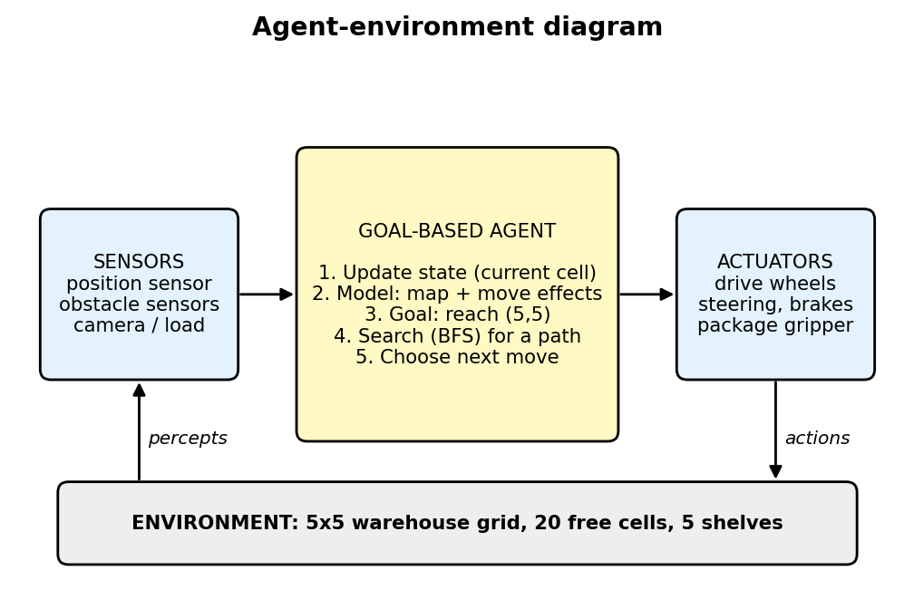
Figure 2: Agent-environment diagram of the goal-based delivery robot

a.3 Environment Properties
Property | Value | Reason
Observability | Fully observable | The grid layout and the robot's own cell are known.
Agents | Single agent | No other robots are modelled.
Determinism | Deterministic | Each move leads to exactly one known next cell.
Episodic / Sequential | Sequential | The current move affects later moves.
Static / Dynamic | Static | Shelves do not move while the robot plans.
Discrete / Continuous | Discrete | Finite set of grid cells and four actions.

Part (b) - Agent Type Classification

b.1 Chosen Agent Type
Goal-based agent.

b.2 Justification Specific to this Scenario
- The task is defined by a goal. Success means reaching (5,5), not reacting to a single percept. The agent must ask "which sequence of moves gets me to (5,5)?", which is what a goal-based agent does.
- A simple reflex agent fails. A rule such as "if free, move Right or Down" can walk into the dead ends (3,2) or (4,3) and get stuck or loop, because it has no memory and no look-ahead.
- Planning is needed because of the shelves. The blocked cells (2,2), (2,3), (3,3), (4,2), (4,4) create dead ends, so the robot must search ahead and choose a path that really reaches the goal.
- A model is available. The map and the effect of each move are known and deterministic, so the agent can simulate moves internally (an internal model plus a goal).
- A utility-based agent is unnecessary. Every move costs 1 and there is no trade-off such as risk versus speed; the only requirement is the shortest path, which uninformed search already provides.

b.3 Comparison of Agent Types

Agent type | Suitable? | Reason
Simple reflex | No | No memory or planning; gets trapped in dead ends.
Model-based reflex | Partially | Tracks the state but has no explicit goal to plan towards.
Goal-based | Yes (best) | Uses the map model and a goal test to search for a path.
Utility-based | Not needed | No competing objectives; uniform step cost.

Part (c) - Formal Search Problem Formulation

c.1 State Space
A state is the robot's cell (r, c) with 1 <= r, c <= 5 and (r, c) not in the blocked set B = {(2,2), (2,3), (3,3), (4,2), (4,4)}. There are 20 valid states.

c.2 Formal Components
Component | Definition
Initial state | s0 = (1,1)
Goal state / goal test | Goal(s) is true if and only if s = (5,5)
Actions | ACTIONS(r,c) is a subset of {Up, Down, Left, Right}. An action is applicable only if the resulting cell lies inside the 5x5 grid and is not in B.
Transition model | RESULT((r,c), Up) = (r-1, c); RESULT((r,c), Down) = (r+1, c); RESULT((r,c), Left) = (r, c-1); RESULT((r,c), Right) = (r, c+1). Moves into the boundary or into B are not allowed.
Path cost | g(path) = sum of step costs; step cost c(s,a,s') = 1 for every move, so g = number of moves.

c.3 Examples of the Transition Model
- ACTIONS(1,1) = {Down, Right} (Up and Left leave the grid); RESULT((1,1), Down) = (2,1); RESULT((1,1), Right) = (1,2).
- ACTIONS(3,2) = {Left} only, because Up (2,2), Down (4,2) and Right (3,3) are blocked: a dead end.
- ACTIONS(5,3) = {Up, Left, Right}: Up leads to (4,3), Left to (5,2), Right to (5,4).

c.4 Python Representation
from collections import deque

GRID_SIZE = 5

BLOCKED = {
(2, 2), (2, 3),
(3, 3),
(4, 2), (4, 4)
}

START, GOAL = (1, 1), (5, 5)

MOVES = [
("Up", -1, 0),
("Down", 1, 0),
("Left", 0, -1),
("Right", 0, 1)
]

def is_goal(state):
return state == GOAL

def successors(state):
r, c = state
result = []

for name, dr, dc in MOVES:
nr, nc = r + dr, c + dc

if (1 <= nr <= GRID_SIZE and
1 <= nc <= GRID_SIZE and
(nr, nc) not in BLOCKED):

result.append((name, (nr, nc)))

return result

def bfs(start, goal):
frontier = deque([start])
parent = {start: None}
action_taken = {start: None}
expanded = 0

while frontier:
state = frontier.popleft()
expanded += 1

print(f"Step {expanded}: expand {state}")

if is_goal(state):
path = []
actions = []
current = state

while current is not None:
path.append(current)

if action_taken[current] is not None:
actions.append(action_taken[current])

current = parent[current]

path.reverse()
actions.reverse()

return path, actions, expanded

for action, child in successors(state):
if child not in parent:
parent[child] = state
action_taken[child] = action
frontier.append(child)

print("Queue:", list(frontier))

return None, None, expanded

path, actions, nodes_expanded = bfs(START, GOAL)

print("\n========== BFS RESULT ==========")

if path:
print("Path:", path)
print("Actions:", actions)
print("Cost:", len(path) - 1)
print("Nodes Expanded:", nodes_expanded)
else:
print("No path found.")

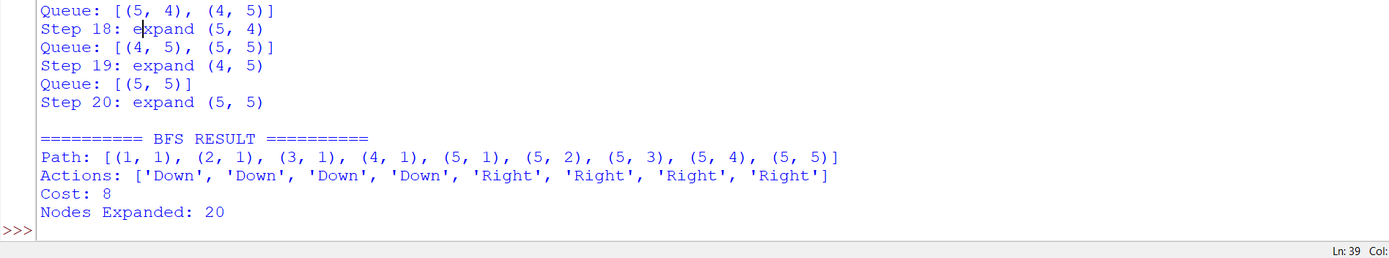
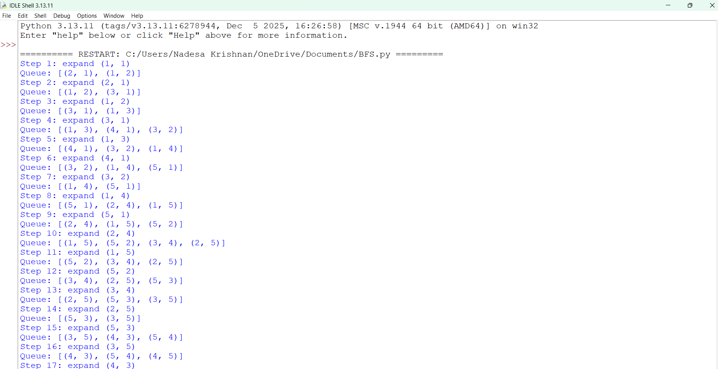
Output:

Part (d) - Breadth-First Search

d.1 Algorithm and Assumptions
BFS uses a FIFO queue as the frontier and expands the shallowest node first. A visited set avoids repeated states. Children are generated in the order Up, Down, Left, Right. The goal test is applied when a node is expanded (removed from the queue).

d.2 Pseudocode
BFS(problem):
frontier <- queue containing START
visited <- {START}
while frontier is not empty:
node <- frontier.dequeue()
if Goal(node): return path(node)
for each (action, child) in successors(node):
if child not in visited:
visited.add(child); parent[child] <- node
frontier.enqueue(child)
return failure

d.3 Flowchart
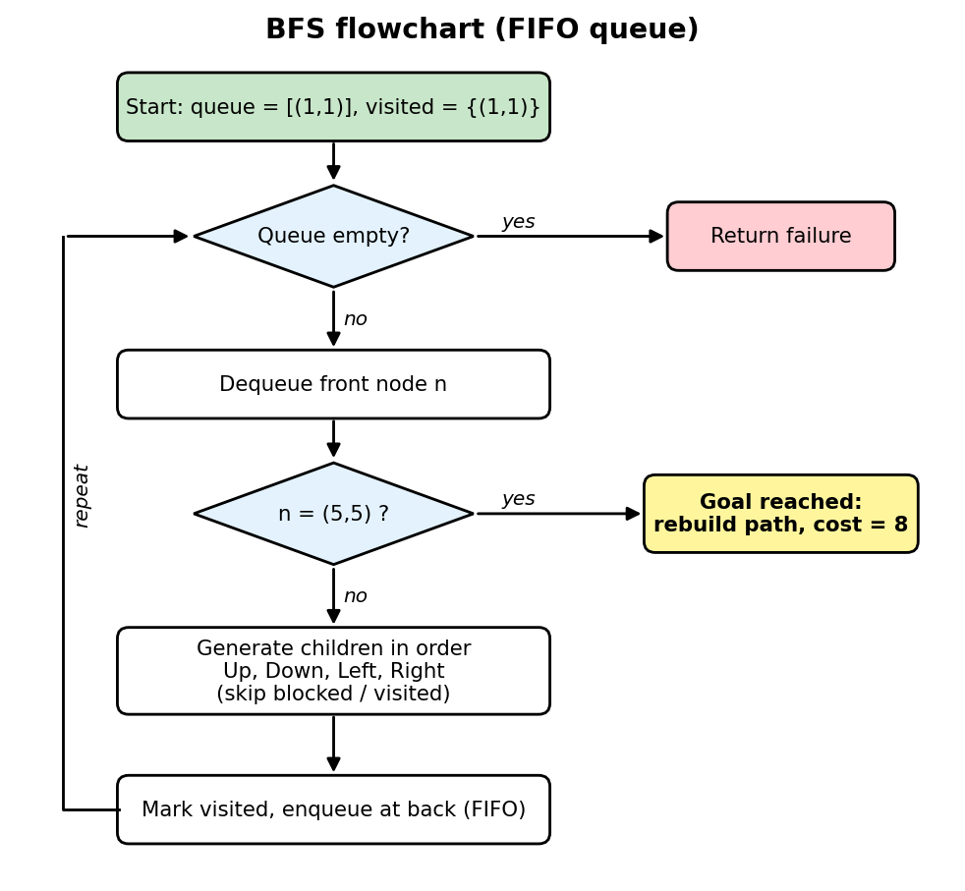
Figure 3: BFS flowchart

d.4 Python Code
from collections import deque
start = (1, 1)
goal = (5, 5)
blocked = {
(2, 2), (2, 3),
(3, 3),
(4, 2), (4, 4)
}
moves = [
(-1, 0), # Up
(1, 0), # Down
(0, -1), # Left
(0, 1) # Right
]
queue = deque([start])
visited = {start}
parent = {start: None}

while queue:
current = queue.popleft()

if current == goal:
break

r, c = current

for dr, dc in moves:
next_cell = (r + dr, c + dc)

if (1 <= next_cell[0] <= 5 and
1 <= next_cell[1] <= 5 and
next_cell not in blocked and
next_cell not in visited):

visited.add(next_cell)
parent[next_cell] = current
queue.append(next_cell)

path = []
current = goal
while current is not None:
path.append(current)
current = parent[current]

path.reverse()

print("BFS Path:")
print(path)
print("Total Cost:", len(path) - 1)

Output :

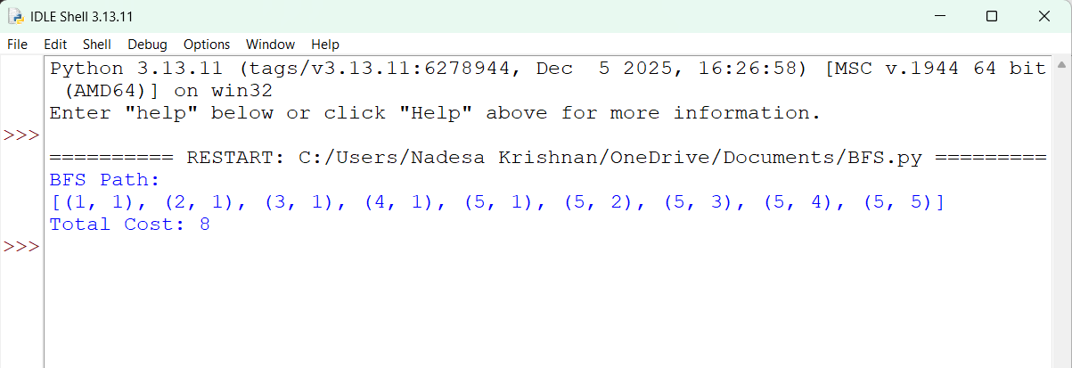

d.5 Step-by-Step Expansion (Queue at Each Step)
The queue is written from front to back.
Step | Node expanded | New nodes added | Queue after the step
1 | (1,1) | (2,1), (1,2) | (2,1), (1,2)
2 | (2,1) | (3,1) | (1,2), (3,1)
3 | (1,2) | (1,3) | (3,1), (1,3)
4 | (3,1) | (4,1), (3,2) | (1,3), (4,1), (3,2)
5 | (1,3) | (1,4) | (4,1), (3,2), (1,4)
6 | (4,1) | (5,1) | (3,2), (1,4), (5,1)
7 | (3,2) | none (dead end) | (1,4), (5,1)
8 | (1,4) | (2,4), (1,5) | (5,1), (2,4), (1,5)
9 | (5,1) | (5,2) | (2,4), (1,5), (5,2)
10 | (2,4) | (3,4), (2,5) | (1,5), (5,2), (3,4), (2,5)
11 | (1,5) | none | (5,2), (3,4), (2,5)
12 | (5,2) | (5,3) | (3,4), (2,5), (5,3)
13 | (3,4) | (3,5) | (2,5), (5,3), (3,5)
14 | (2,5) | none | (5,3), (3,5)
15 | (5,3) | (4,3), (5,4) | (3,5), (4,3), (5,4)
16 | (3,5) | (4,5) | (4,3), (5,4), (4,5)
17 | (4,3) | none (dead end) | (5,4), (4,5)
18 | (5,4) | (5,5) | (4,5), (5,5)
19 | (4,5) | none | (5,5)
20 | (5,5) | GOAL REACHED | empty

d.6 Expansion by Depth Level
Depth | Nodes at this depth
0 | (1,1)
1 | (2,1), (1,2)
2 | (3,1), (1,3)
3 | (4,1), (3,2), (1,4)
4 | (5,1), (2,4), (1,5)
5 | (5,2), (3,4), (2,5)
6 | (5,3), (3,5)
7 | (4,3), (5,4), (4,5)
8 | (5,5)

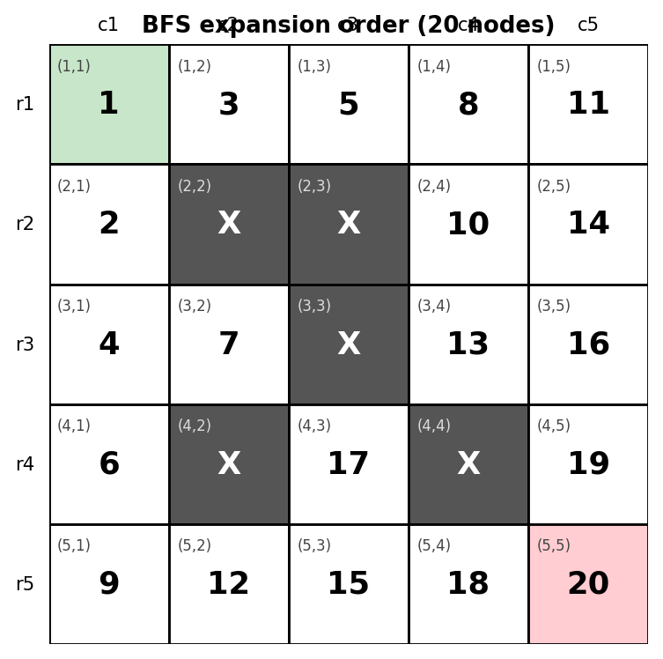
Figure 4: BFS expansion order on the grid

d.7 Final Result
- Path: (1,1) -> (2,1) -> (3,1) -> (4,1) -> (5,1) -> (5,2) -> (5,3) -> (5,4) -> (5,5)
- Actions: Down, Down, Down, Down, Right, Right, Right, Right
- Total cost: 8 (equal to the Manhattan lower bound, so the path is optimal)
- Nodes expanded: 20 (every reachable free cell)
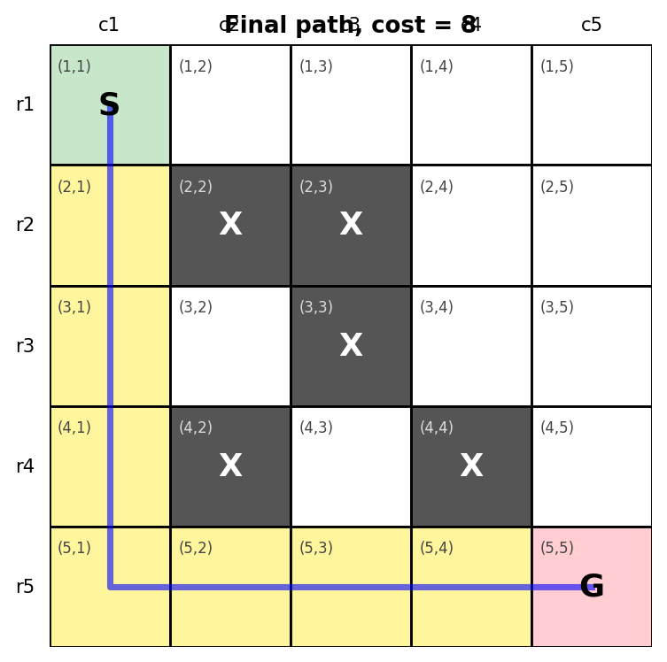
Figure 5: Final path found by BFS (cost = 8)

Interpretation: the robot goes down the left aisle and then along the bottom aisle to the goal. Because the goal is at the deepest level (depth 8), BFS had to expand all 20 reachable cells first, including the dead ends (3,2) and (4,3).

Part (e) - Depth-First Search

e.1 Algorithm and Assumptions
DFS uses a LIFO stack as the frontier and always expands the deepest node. Neighbours are explored in the order Up, Down, Left, Right, so they are pushed in reverse order (Right first, Up last) and Up is popped first. An explored set prevents loops. The goal test is applied when a node is popped.

e.2 Pseudocode
DFS(problem):
stack <- [(START, None)]
explored <- {}
while stack is not empty:
(node, par) <- stack.pop()
if node in explored: continue
explored.add(node); parent[node] <- par
if Goal(node): return path(node)
for each child in reversed(successors(node)):
if child not in explored: stack.push((child, node))
return failure

e.3 Flowchart
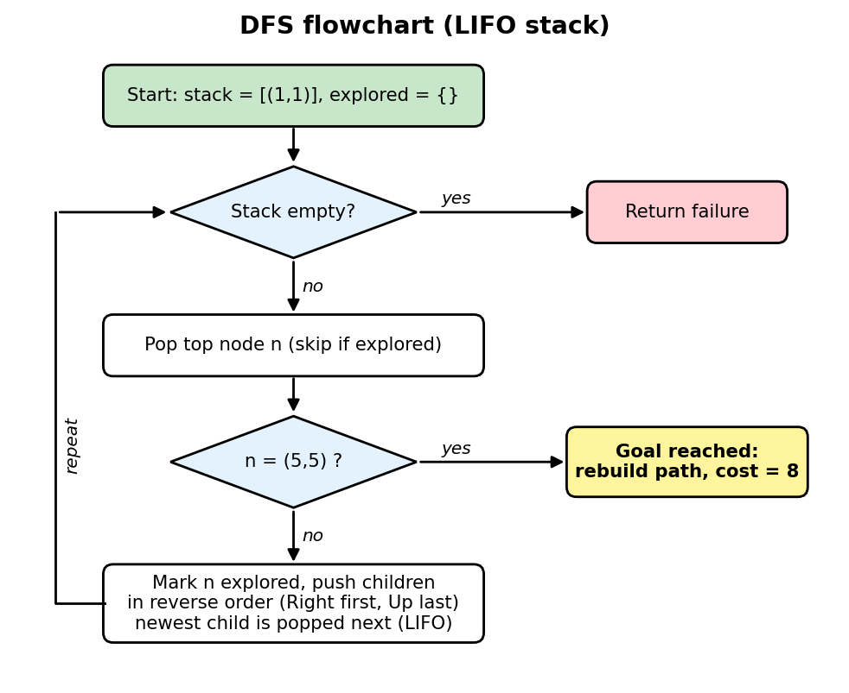
Figure 6: DFS flowchart

e.4 Python Code
start = (1, 1)
goal = (5, 5)

blocked = {
(2, 2), (2, 3),
(3, 3),
(4, 2), (4, 4)
}

moves = [
(-1, 0), # Up
(1, 0), # Down
(0, -1), # Left
(0, 1) # Right
]

stack = [start]
visited = {start}
parent = {start: None}

while stack:
current = stack.pop()

if current == goal:
break

r, c = current

for dr, dc in reversed(moves):
next_cell = (r + dr, c + dc)

if (1 <= next_cell[0] <= 5 and
1 <= next_cell[1] <= 5 and
next_cell not in blocked and
next_cell not in visited):

visited.add(next_cell)
parent[next_cell] = current
stack.append(next_cell)

path = []
current = goal

while current is not None:
path.append(current)
current = parent[current]

path.reverse()

print("DFS Path:")
print(path)
print("Total Cost:", len(path) - 1)

Output :

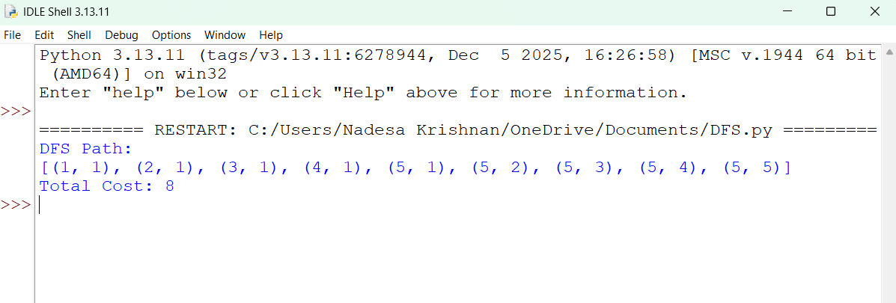

e.5 Step-by-Step Expansion (Stack at Each Step)
The stack is written from bottom to top; the rightmost entry is popped next.
Step | Node popped / expanded | Children pushed | Stack after the step (bottom -> top)
1 | (1,1) | (2,1), (1,2) | (1,2), (2,1)
2 | (2,1) | (3,1) | (1,2), (3,1)
3 | (3,1) | (4,1), (3,2) | (1,2), (3,2), (4,1)
4 | (4,1) | (5,1) | (1,2), (3,2), (5,1)
5 | (5,1) | (5,2) | (1,2), (3,2), (5,2)
6 | (5,2) | (5,3) | (1,2), (3,2), (5,3)
7 | (5,3) | (4,3), (5,4) | (1,2), (3,2), (5,4), (4,3)
8 | (4,3) | none (dead end, backtrack) | (1,2), (3,2), (5,4)
9 | (5,4) | (5,5) | (1,2), (3,2), (5,5)
10 | (5,5) | GOAL REACHED | (1,2), (3,2) left unexplored

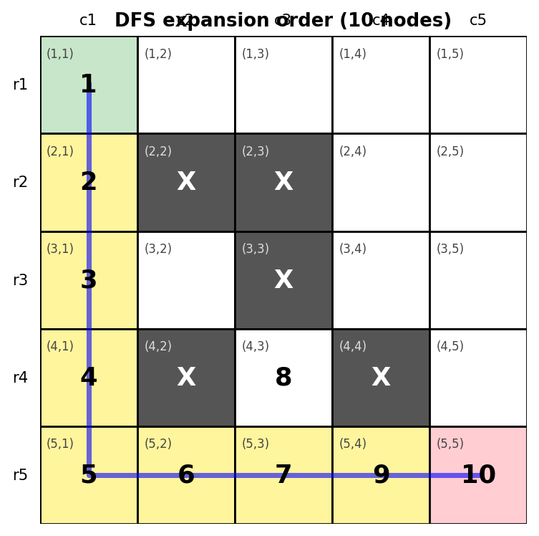
Figure 7: DFS expansion order and final path

e.6 Final Result
- Path: (1,1) -> (2,1) -> (3,1) -> (4,1) -> (5,1) -> (5,2) -> (5,3) -> (5,4) -> (5,5)
- Total cost: 8
- Nodes expanded: 10 (out of 20 free cells)
- Backtracking: one backtrack, at the dead end (4,3).

Interpretation: with the order Up, Down, Left, Right, DFS dives down the left column, runs along the bottom row, backtracks once from (4,3) and reaches the goal after only 10 expansions. It found a cost-8 path here, but this is a consequence of the chosen neighbour order: DFS does not guarantee the shortest path. In another layout or order it could return a longer route.

Part (f) - Comparison of BFS and DFS
Let b = branching factor (at most 4 here, about 2-3 in practice), d = depth of the shallowest goal (d = 8) and m = maximum depth of the search tree (bounded by the 20 states in graph search).

f.1 Comparison Table
Criterion | BFS | DFS | Application to this problem
Completeness | Complete (finite b, finite grid) | Complete only with repeated-state checking on a finite grid | Both are complete here: a visited/explored set is used and the grid has only 20 states.
Optimality | Optimal for uniform step cost | Not optimal in general | BFS guarantees cost 8; DFS reached cost 8 because of the neighbour order.
Time complexity | O(b^d) | O(b^m) | BFS expanded 20 nodes; DFS expanded 10 (its worst case can also reach 20).
Space complexity | O(b^d): whole frontier stored | O(b*m): current path and siblings | Memory is not a concern on a 20-state grid (peak queue and stack size were both 4).
Data structure | FIFO queue | LIFO stack | -

f.2 Measured Results
Metric | BFS | DFS
Path cost | 8 | 8
Nodes expanded | 20 | 10
Dead ends visited | (3,2), (4,3) | (4,3)
Guaranteed shortest | Yes | No

f.3 Which Algorithm is More Suitable?
BFS is more suitable for this warehouse delivery problem.
- The robot's performance measure is the shortest path and every move costs 1. BFS is guaranteed to return the minimum-cost path; DFS gives no such guarantee.
- The state space is tiny (20 states), so BFS's higher memory use and extra expansions are negligible; DFS's memory advantage does not matter.
- Warehouse layouts change (shelves added or moved). BFS stays correct for any layout, whereas DFS's result depends on the neighbour order and could produce a long detour that wastes battery and time.
- DFS is attractive only when memory is very limited, the grid is huge, or any solution (not the best) is acceptable. None of these applies here.

Conclusion
The warehouse delivery problem can be modeled as a goal-based intelligent agent operating in a discrete grid environment. The robot starts at (1,1) and must reach (5,5) while avoiding blocked cells.
The problem can be formulated as a search problem using an initial state, goal state, actions, transition model, and path-cost function. Both BFS and DFS can find a solution in this finite warehouse environment.
For the given movement ordering, both algorithms produce an 8-movement path. However, BFS is the more appropriate algorithm because every movement has equal cost and BFS guarantees a shortest path. DFS does not guarantee optimality and may return a longer route depending on the order in which nodes are explored.

